Infosys Springboard Virtual Internship 6.0 Completion Report

Team Details
Batch Number: 7
Team C
TrackMile: AI-Powered Smart Delivery & Logistics System
Start date : 11-11-2025
Names:
• Mehek Fatima Shaik – Frontend Development & User Role Authentication
• Tejas Thakor – Backend Development
• Subhashini – Frontend Development
• Harshavarthini – Frontend Development
• Ayush Kale – AI / Machine Learning Integration
Internship Duration: 6 weeks

1. Project Title
TrackMile: AI-Powered Smart Delivery & Logistics System

2. Project Objective
The objective of my contribution to the TrackMile project was to design and implement a responsive and user-friendly frontend interface along with a secure user role authentication system. The focus was on developing login and account creation functionality, enabling role-based redirection for Admin and Driver users, and enforcing protected routes to prevent unauthorized access. Additionally, the objective included integrating frontend components with backend REST APIs for seamless data flow, managing authentication tokens securely to maintain user sessions, and enhancing overall user experience through intuitive navigation, validation, and error handling. Through this work, the aim was to deliver a secure, scalable, and reliable frontend solution suitable for real-world logistics applications.

3. Project description in detail
As part of the TrackMile project, my primary responsibility was frontend development and user role authentication. I worked on building the user interface using React.js, focusing on clean design, responsiveness, and ease of use. I implemented login and registration functionality that allows users to securely access the system.
After authentication, role-based routing was applied to ensure that users are redirected to the appropriate dashboard based on their role (Admin or Driver). I also worked on integrating frontend components with backend REST APIs to fetch and display real-time data such as delivery details and dashboard information.
Special attention was given to protected routes so that unauthorized users cannot access restricted pages. Overall, my contribution ensured that the application is easy to navigate, secure, and aligned with real-world logistics system requirements from a user perspective.

4. Timeline Overview
Week | Activities Planned | Activities Completed
Week 1 | Understanding project requirements and frontend responsibilities | Analyzed requirements related to UI, authentication, and dashboards
Week 2 |  | Designed login, registration, and role-based navigation flow
  Designing frontend layout and authentication flow
Week 3 |  | Implemented login, signup, and protected routing
  Developing authentication and basic UI components
Week 4 |  | Developed Admin and Driver dashboard interfaces
  Dashboard UI development
Week 5 | API integration and role validation | Integrated frontend with backend APIs and ensured role-based access
Week 6 | Testing, UI refinement, and documentation | Tested authentication flow, fixed UI issues, and finalized frontend documentation

5a. Key Milestones
Milestone | Description
Project Kickoff | Understood project objectives and my role in frontend development and authentication.
Prototype/First Draft | Designed and implemented initial login, registration, and dashboard UI layouts..
Mid-Term Review | Improved UI design and refined role-based routing based on feedback.
Final Submission | .
  Completed frontend integration with backend APIs and finalized authentication flow.
Presentation | Presented my frontend work, explaining authentication logic and dashboard navigation.

5b. Project execution details
• Requirement Analysis – Analyzed user requirements related to login, dashboards, and role-based access.
• UI Design – Designed responsive layouts for login, registration, Admin dashboard, and Driver dashboard.
• Frontend Development – Implemented React components for authentication and dashboard pages.
• Role-Based Routing – Ensured users are redirected to the correct dashboard based on role.
• Authentication Handling – Integrated JWT-based authentication with backend APIs.
• Protected Routes – Restricted unauthorized access to secure pages.
• API Integration – Connected frontend components with backend REST APIs.
• Testing & Refinement – Tested authentication flows and fixed UI and navigation issues.

6. Snapshots / Screenshots

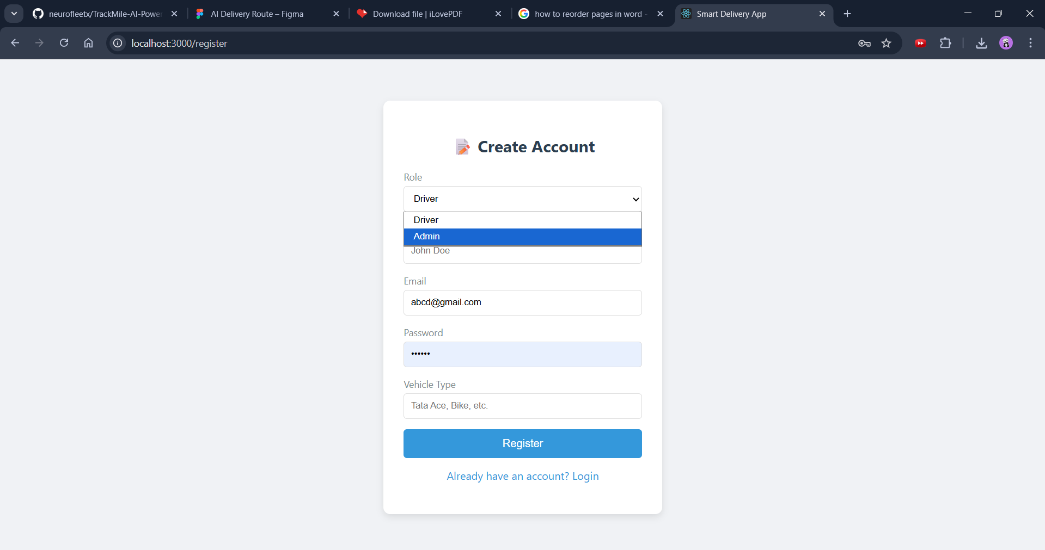

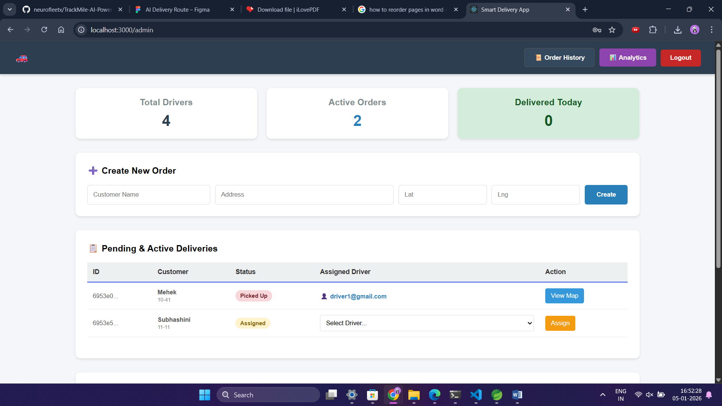

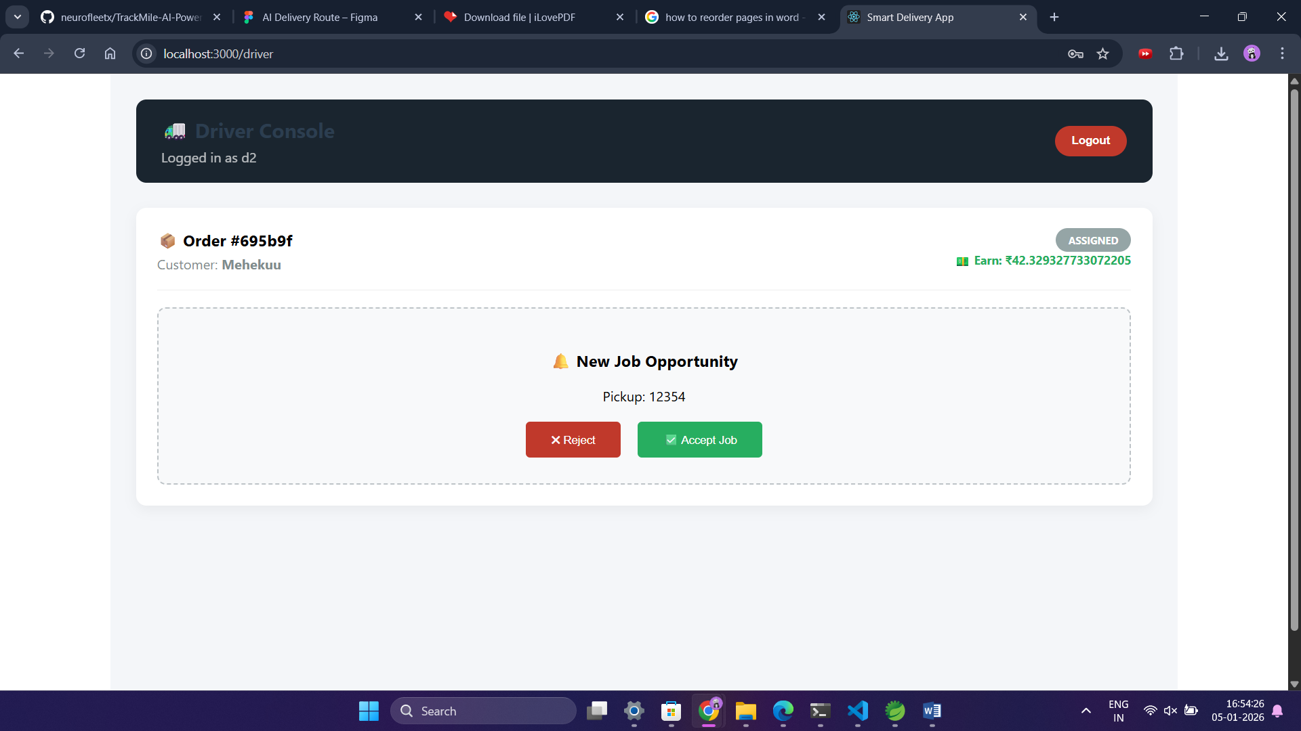

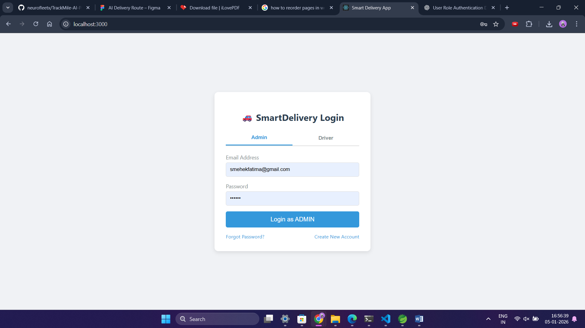

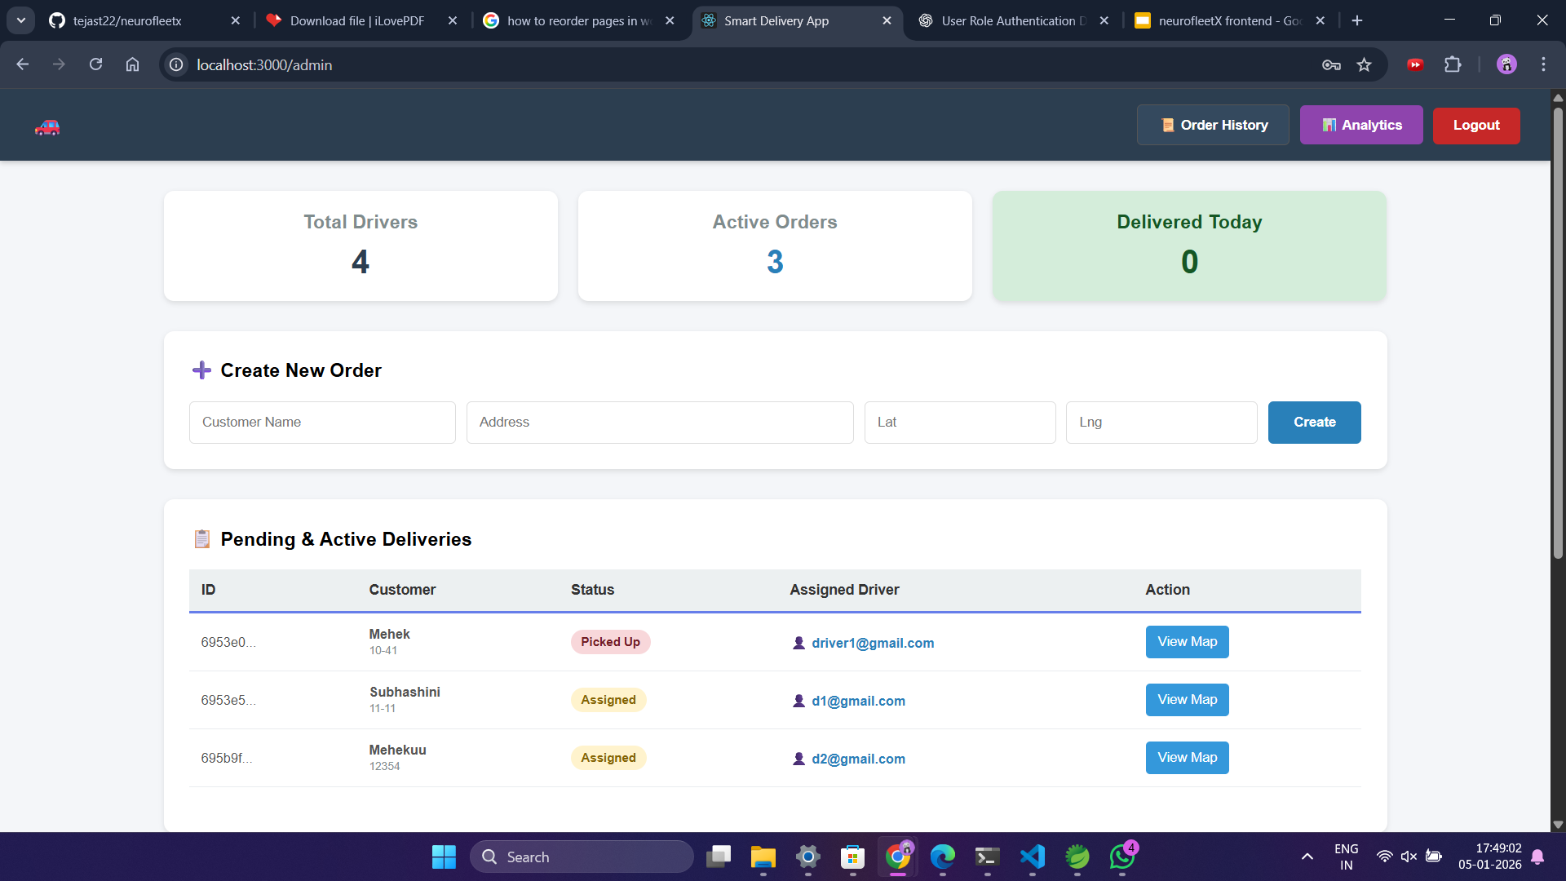

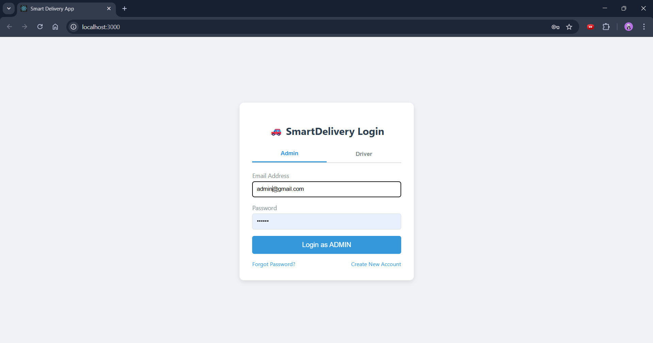

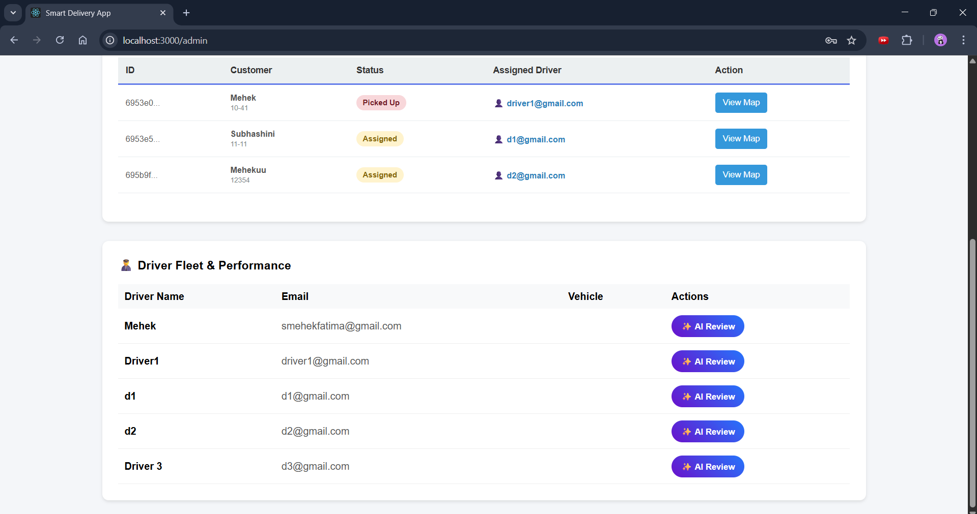

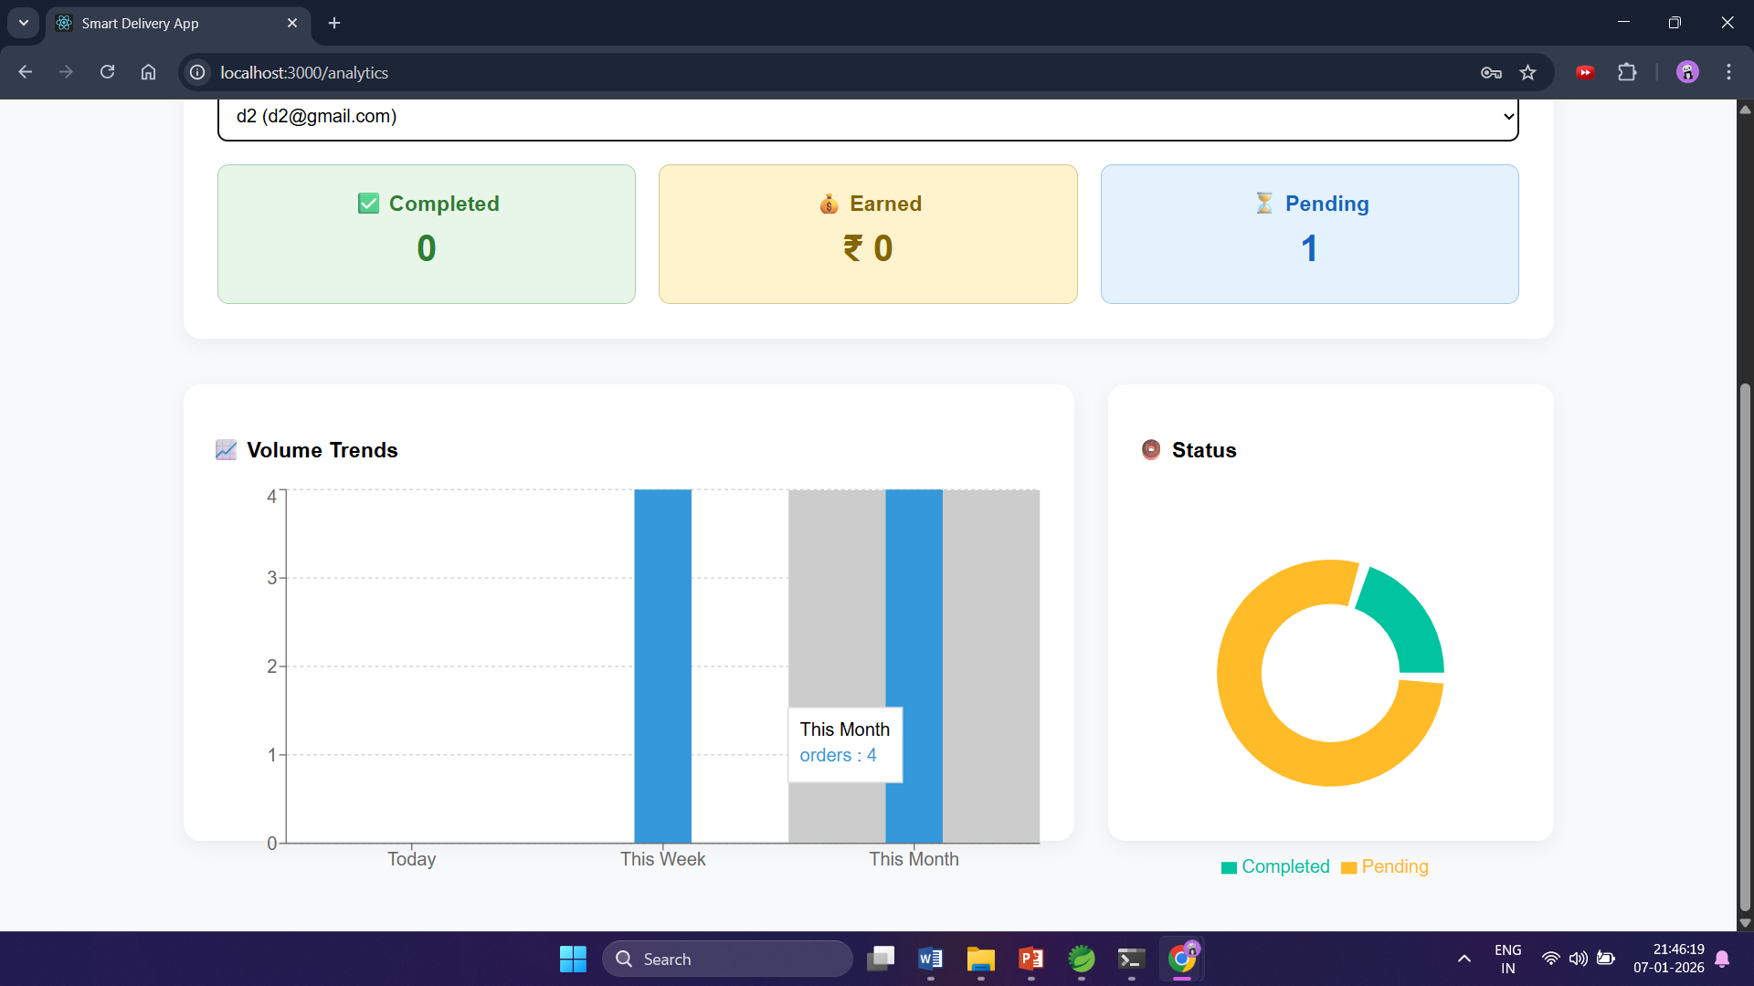

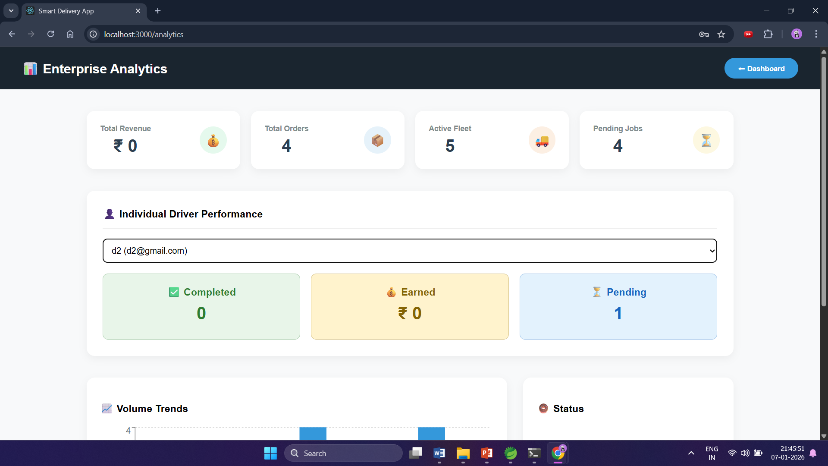

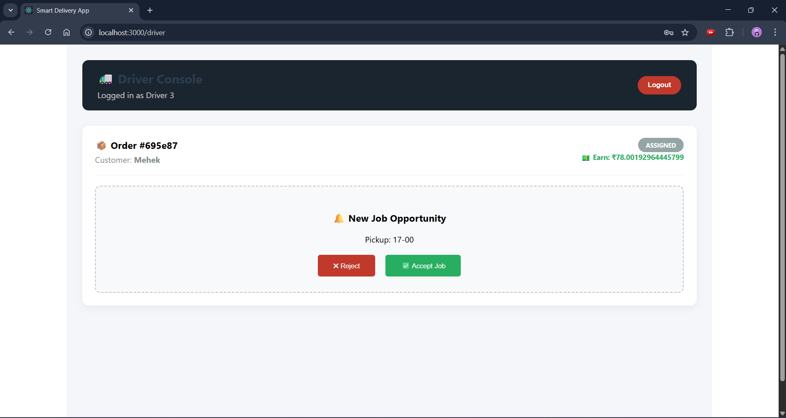

7. Challenges Faced
• Implementing secure role-based routing for Admin and Driver users
• Managing authentication tokens and maintaining user sessions
• Ensuring protected routes to prevent unauthorized access
• Integrating frontend components with backend REST APIs
• Handling asynchronous data fetching and error scenarios
• Designing dashboards that are both user-friendly and responsive
• Debugging UI issues and improving navigation flow

8. Learnings & Skills Acquired

• Hands-on experience with React.js frontend development
• Implementation of login, registration, and role-based authentication
• Understanding of JWT handling and session management
• Experience with protected routes and access control
• Integration of frontend with backend APIs
• Improved skills in UI/UX design and responsiveness
• Debugging, testing, and refining frontend applications

9. Testimonials from team
Team Member 1:
“The contributor effectively handled frontend development and implemented secure user role authentication, enabling smooth login and role-based navigation.”
Team Member 2:
“The contributor designed responsive and user-friendly interfaces that improved the overall usability of the dashboards.”
Team Member 3:
“The contributor ensured proper role-based routing and integrated frontend components with backend APIs for controlled access.”
Team Member 4:
“The contributor demonstrated strong problem-solving skills while implementing protected routes and refining frontend workflows.”
Team Member 5:
“The contributor’s work on frontend development and authentication significantly enhanced the security and user experience of the application.”

10. Conclusion
In conclusion, my contribution to the TrackMile project primarily focused on frontend development and user role authentication. I successfully implemented secure login and registration functionality, role-based access control, and protected routing to ensure that users could access only authorized sections of the application. This project helped me gain practical exposure to real-world frontend development challenges and strengthened my understanding of secure web application design.

11. Acknowledgements
I would like to express my sincere gratitude to Infosys Springboard for providing the opportunity to participate in this virtual internship program. I am especially thankful to my mentor for the continuous guidance, encouragement, and valuable feedback provided throughout the internship, which played a crucial role in shaping my understanding and successful completion of the project. I also extend my heartfelt appreciation to my teammates for their constant support, collaboration, and cooperation, which greatly contributed to the smooth execution and overall success of this project.
Finally, I appreciate everyone who contributed directly or indirectly to my learning and the completion of this project.

